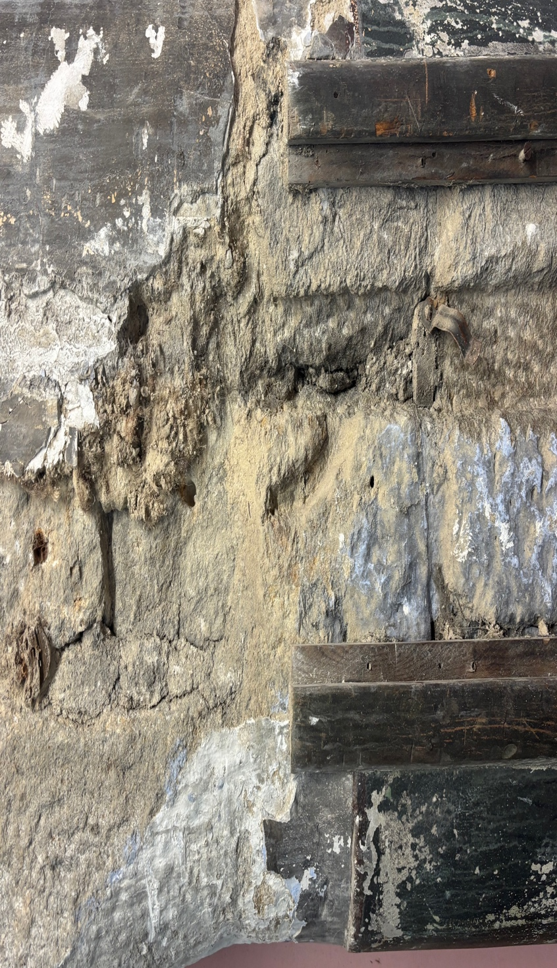
9a Project Space
Robinwood Mill
Photography brief

1. Brief Overview

Brief title: Imagery for organisation/brand launch
Organisation: 9a Project Space (CIC)
Location: Robinwood Mill and surrounding areas, Todmorden, Calder Valley
Timeline: Submission of images date 7 June 2026

About us:

9a Project Space is a dedicated art space rooted in place and committed to building a creative community that’s open, enquiring and experimental. We provide space for people to come together, create and connect, exploring our histories and possible futures. Based in a nineteenth century spinning mill, built over the River Calder, we envision 9a Project Space as a deliberately leaky structure; one that facilitates flows of creative exchange between artists, communities and the distinct landscapes of the Upper Calder Valley. Whilst connected to Calderdale’s broader art ecosystem, 9a has a particular focus on the communities adjacent to our base at Robinwood Mill, and the unique geography of Calderdale’s Western edge. 9a occupies part of the second floor of the Mill, Robinwood, which sits in an area where the arts offer is low, and where community space is at a premium due to the geography of a steep-sided valley. Our goal is to raise the arts offer in this part of the borough, while developing a specific creative concern around rural landscapes, community and sustainability in Cornholme, Lydgate, Portsmouth and Todmorden.
https://9aprojectspace.org

Brief summary:
We are seeking a photographer to create strong imagery to support the identity of a new community interest organisation in Todmorden. We will use these assets on our website, on socials, on publicity, in reports and funding bids.

2. Objectives
Capture high-quality, engaging visual documentation of our organisation and its location
Reflect the relationship between art, community and landscape
Build a strong image library for marketing, fundraising and reporting
Communicate the atmosphere and ethos of 9a (open, experimental, rooted in place)

3. Scope of Work
Key tasks / deliverables:
Photograph the landscape and local area adjacent to 9a. Document artists in the studios at Robinwood and local residents.

Capture a mix of:
Portraits (residents, participants, facilitators)
Environmental / landscape context where relevant
Edit and deliver a curated selection of high-resolution images
Provide web-ready versions for digital use

Outputs:
[e.g. 30–80 edited image)]
Usage rights for 9a across marketing, press and reporting
Out of scope:
Videography (unless agreed separately)
Extensive retouching beyond standard edits (specify how many edits)

4. Audience
Residents in the Calder Valley
Artists and creative practitioners
Arts organisation and cultural sector
Funders and partners
Wider arts audiences (regional/national)

5. Tone & Approach
We are looking for work that is:
Honest, human and non-staged
Sensitive to community contexts
Artistically aware and visually strong
Attentive to space, texture and environment

6. Timeline & Milestones
Initial shoot(s): Between 11- 31 May 2026
Image delivery: 7 June 2026
Ongoing / repeat commissions possible

7. Budget
Fee: £300 project (inclusive of editing, travel and VAT). Alongside this we offer a solo exhibition opportunity (minimum 2 weeks) at 9a Gallery (or online). Exhibition to take place in 9a Project Space’s first year of operation (April 2026-March 2027). This excludes costs of prints/framing/installation, although we can support you in making a funding application to cover these costs.

8. Practical Considerations
On-site at Robinwood Mill and surrounding areas
Consent and safeguarding awareness required when photographing participants

9. Working with Us
You’ll work with the Directors (Kelly Loughlin & Julia Turpin)
Light-touch, collaborative approach

10. How to Apply
Please complete this online application form including links to your
online portfolio (relevant examples, especially arts/landscape/community work)

Deadline to apply: Friday 8 May 2026

